17-7-26 QUERY PROCESSING FOR DATA SCIENCE SIDDARTH.P

3.Write a Pandas program to display the details of jobs in descending sequence on job
title.
JOB_ID | JOB_TITLE | MIN_SALARY | MAX_SALARY
AD_PRES | President | 20080 | 40000
AD_VP | Administration Vice President | 15000 | 30000
IT_PROG | Programmer | 4000 | 10000
SA_MAN | Sales Manager | 10000 | 20080
SA_REP | Sales Representative | 6000 | 12008

Code:
import pandas as pd
df = pd.read_csv("jobs.csv")
print(df.sort_values(by='JOB_TITLE', ascending=False))

Output:

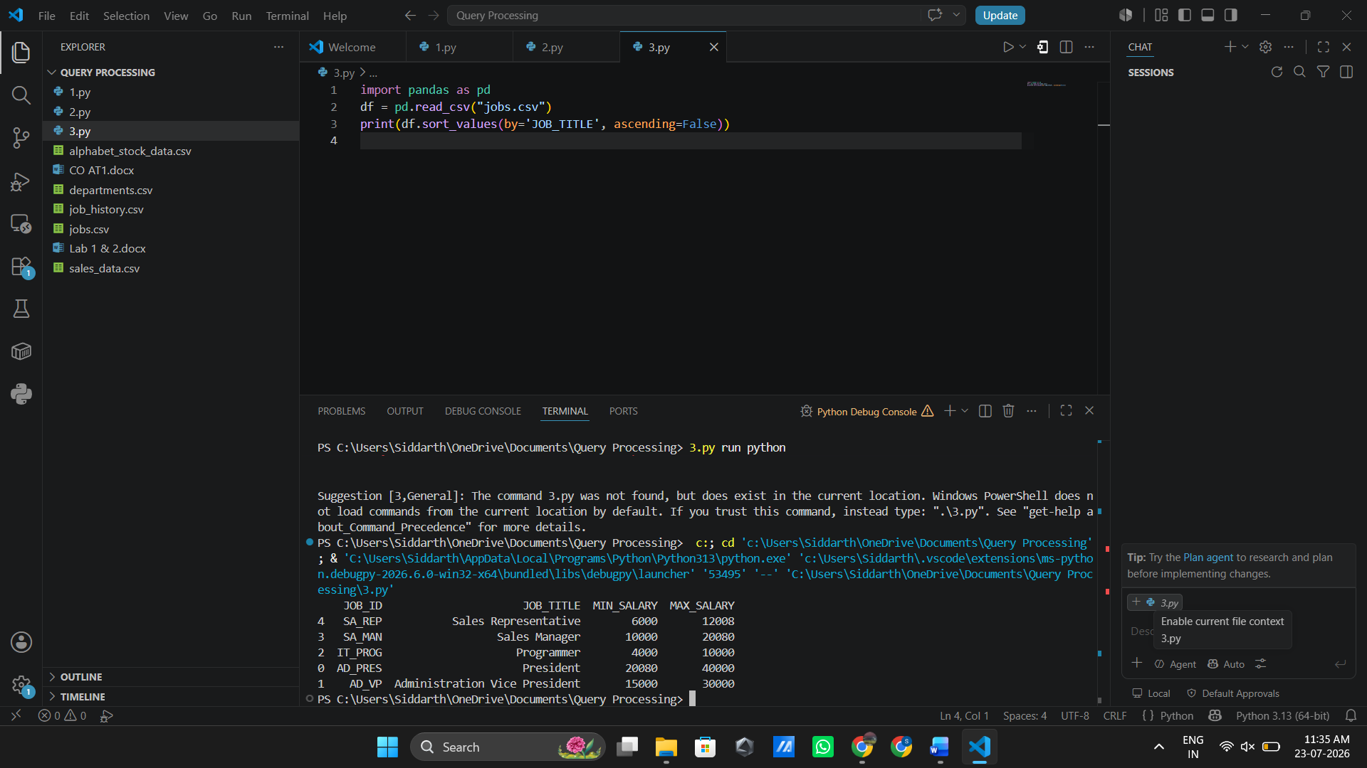
4.Write a Pandas program to create a line plot of the historical stock prices of Alphabet
Inc. between two specific dates.
Date | Open | High | Low | Close | Volume
2016-10-03 | 774.25 | 776.06 | 769.50 | 772.55 | 1500000
2016-10-04 | 776.03 | 778.71 | 772.89 | 776.42 | 1400000
2016-10-05 | 779.30 | 782.07 | 775.65 | 776.46 | 1300000
2016-10-06 | 779.00 | 780.47 | 775.53 | 776.85 | 1200000
2016-10-07 | 779.65 | 779.65 | 770.75 | 775.08 | 1100000

Code:
import pandas as pd
import matplotlib.pyplot as plt

df = pd.read_csv("alphabet_stock_data.csv", parse_dates=['Date'])
data = df[(df['Date'] >= '2016-10-03') & (df['Date'] <= '2016-10-07')]
plt.plot(data['Date'], data['Close'])
plt.xlabel("Date")
plt.ylabel("Close Price")
plt.title("Alphabet Stock Price")
Output:
